PROGRAM:

#To find average of number:

n=int(input("Enter Number of Elements"))

a=[]

for i in range(0,n):

elm=int(input("Enter the Element"))

a.append(elm)

avg=sum(a)/n

print("Average = ",round(avg,1))

OUTPUT:

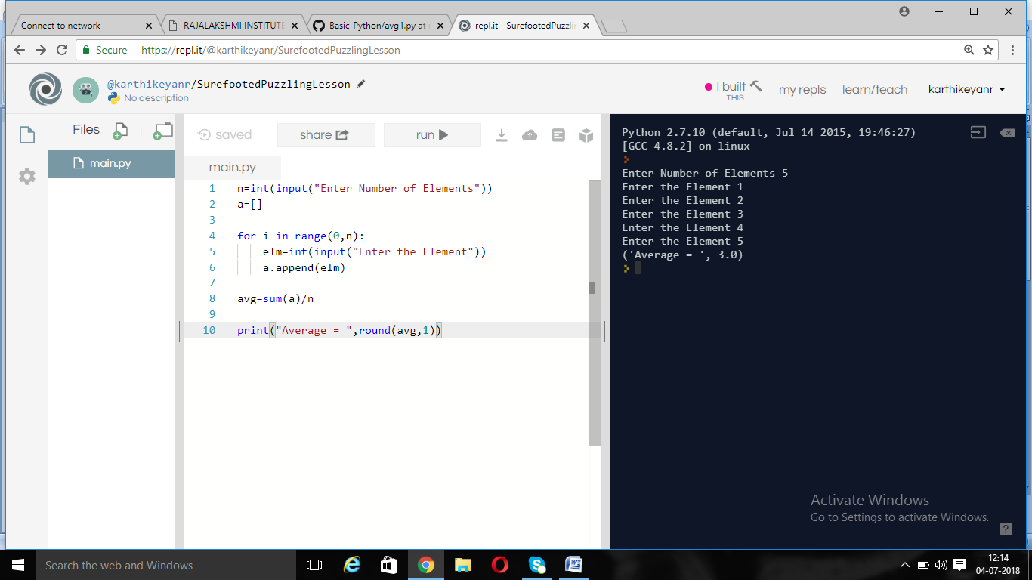

PROGRAM:

#Combination program:

a=int(input("Enter first number:"))

b=int(input("Enter second number:"))

c=int(input("Enter third number:"))

d=[]

d.append(a)

d.append(b)

d.append(c)

for i in range(0,3):

for j in range(0,3):

for k in range(0,3):

if(i!=j and j!=k and k!=i):

print(d[i],d[j],d[k])

OUTPUT:

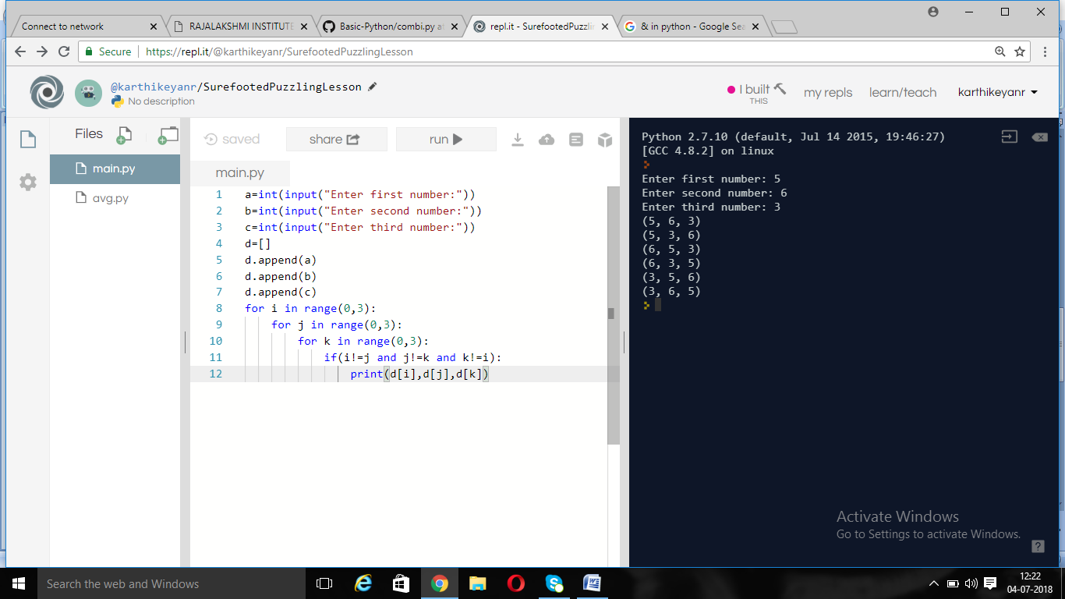

PROGRAM:

#Divisior program:

lower=input("Enter lower limit")

upper=input("Enter Upper limit")

n=input("Enter the divisor")

for i in range(lower,upper+1):

if(i%n==0):

print(i)

OUTPUT:

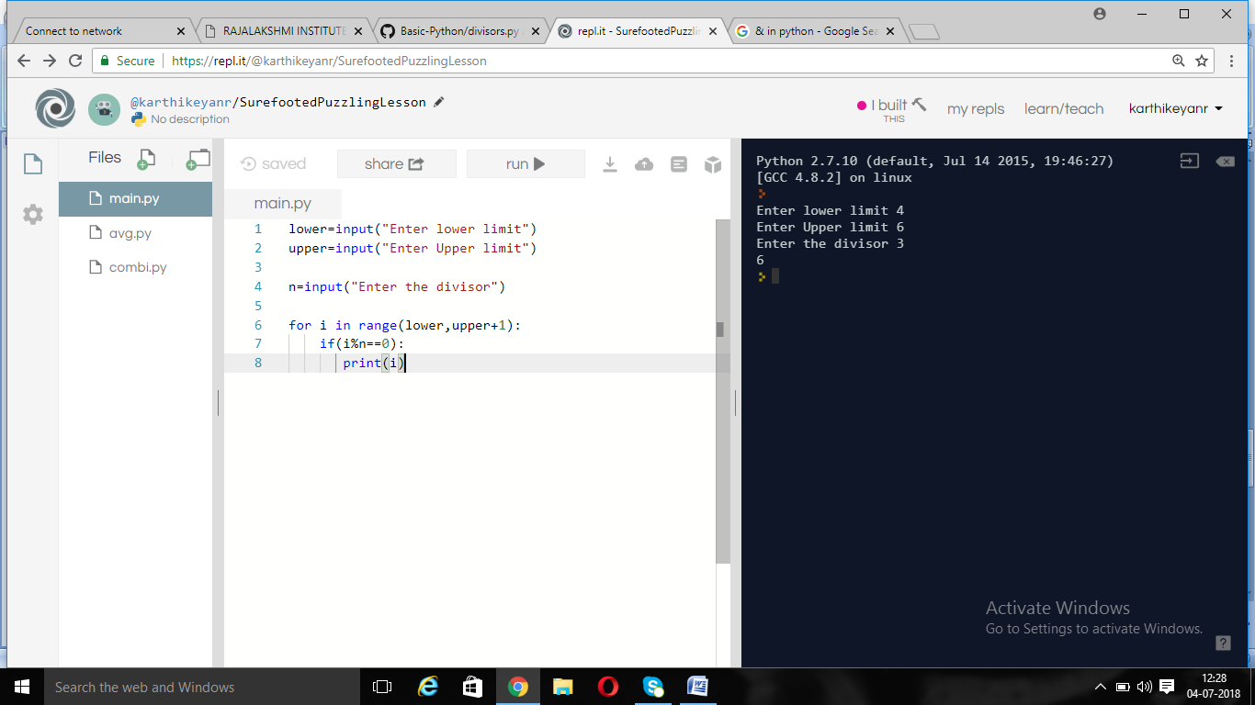

PROGRAM:

|  |
| --- |
| #Divisior program1 |
| number=input("Enter the number") |
|  |

|  |
| --- |
| a=[] |
|  |

|  |
| --- |
| for i in range(2,number+1): |
|  |

|  |
| --- |
| if(number%i==0): |
|  |

|  |
| --- |
| a.append(i); |
|  |

|  |
| --- |
|  |
|  |

|  |
| --- |
| print(a) |
|  |

|  |
| --- |
|  |
|  |

|  |
| --- |
| print("Small Divisor",min(a)) |
|  |

|  |
| --- |
|  |
|  |

|  |
| --- |
|  |
|  |

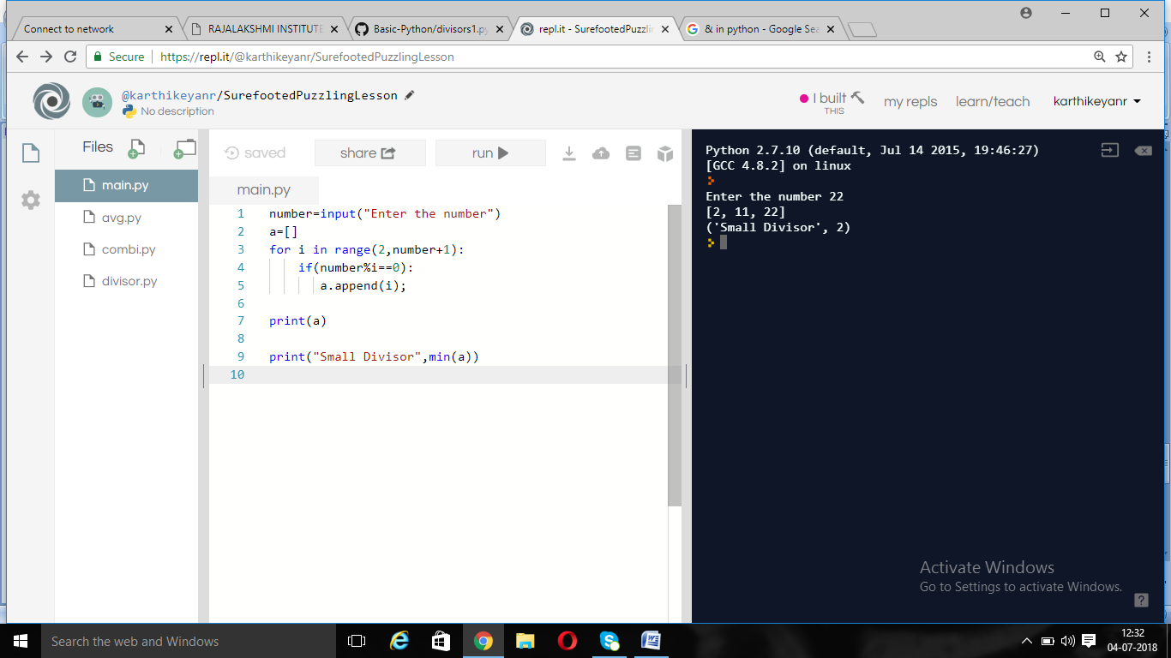

PROGRAM:

#Grade program:

|  |
| --- |
| ub1=int(input("Enter marks of the first subject: ")) |
|  | sub2=int(input("Enter marks of the second subject: ")) |
|  | sub3=int(input("Enter marks of the third subject: ")) |
|  | sub4=int(input("Enter marks of the fourth subject: ")) |
|  | sub5=int(input("Enter marks of the fifth subject: ")) |
|  | avg=(sub1+sub2+sub3+sub4+sub4)/5 |
|  | if(avg>=90): |
|  | print("Grade: A") |
|  | elif(avg>=80 and avg<90): |
|  | print("Grade: B") |
|  | elif(avg>=70 and avg<80): |
|  | print("Grade: C") |
|  | elif(avg>=60 and avg<70): |
|  | print("Grade: D") |
|  | else: |
|  | print("Grade: F") |

OUTPUT:

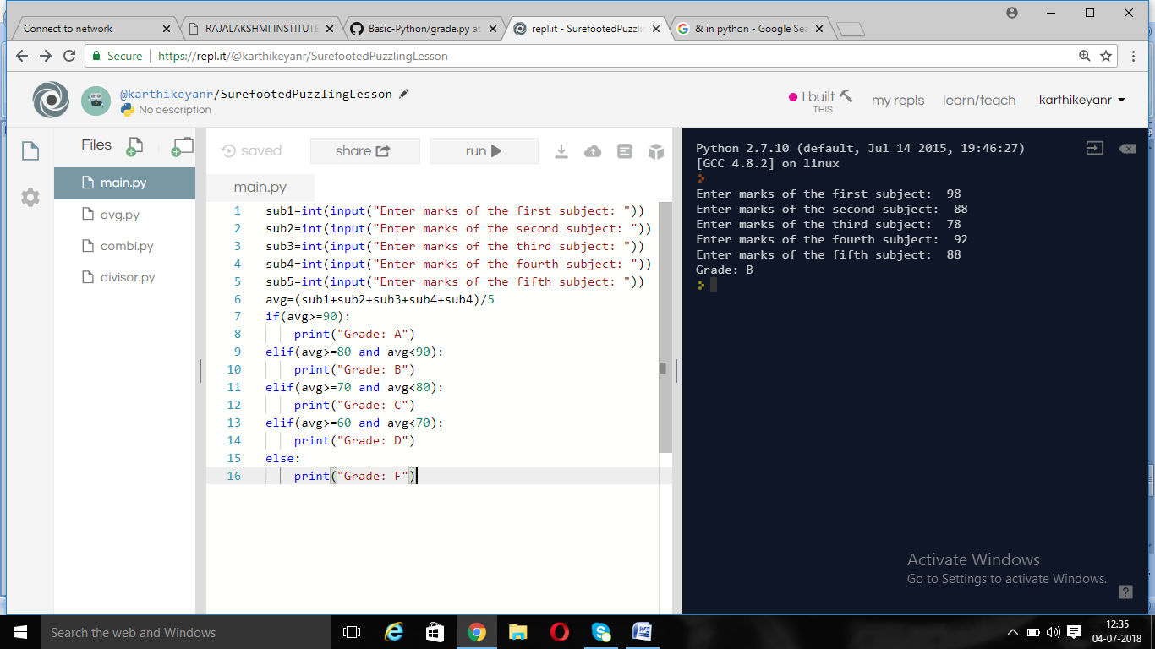

PROGRAM:

#Imatrix program:

from __future__ import print_function

n=input("Enter the size of matrix")

for i in range(1,n+1):

for j in range(1,n+1):

if(i==j):

print("1 ",sep="",end="")

else:

print("0 ",sep="",end="")

print()

OUTPUT:

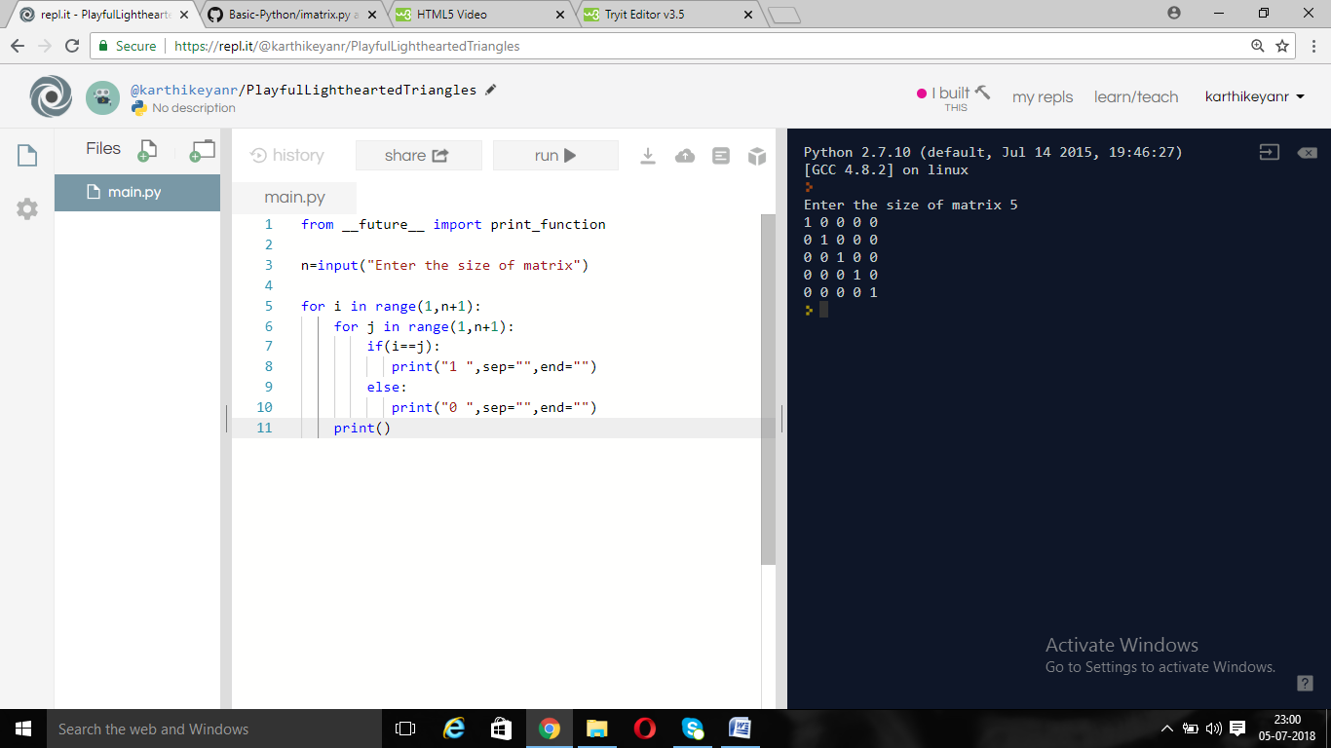

PROGRAM:

#Invertstar program:

n=int(input("Enter number of rows: "))

for i in range (n,0,-1):

print((n-i) * ' ' + i * '*')

OUTPUT:

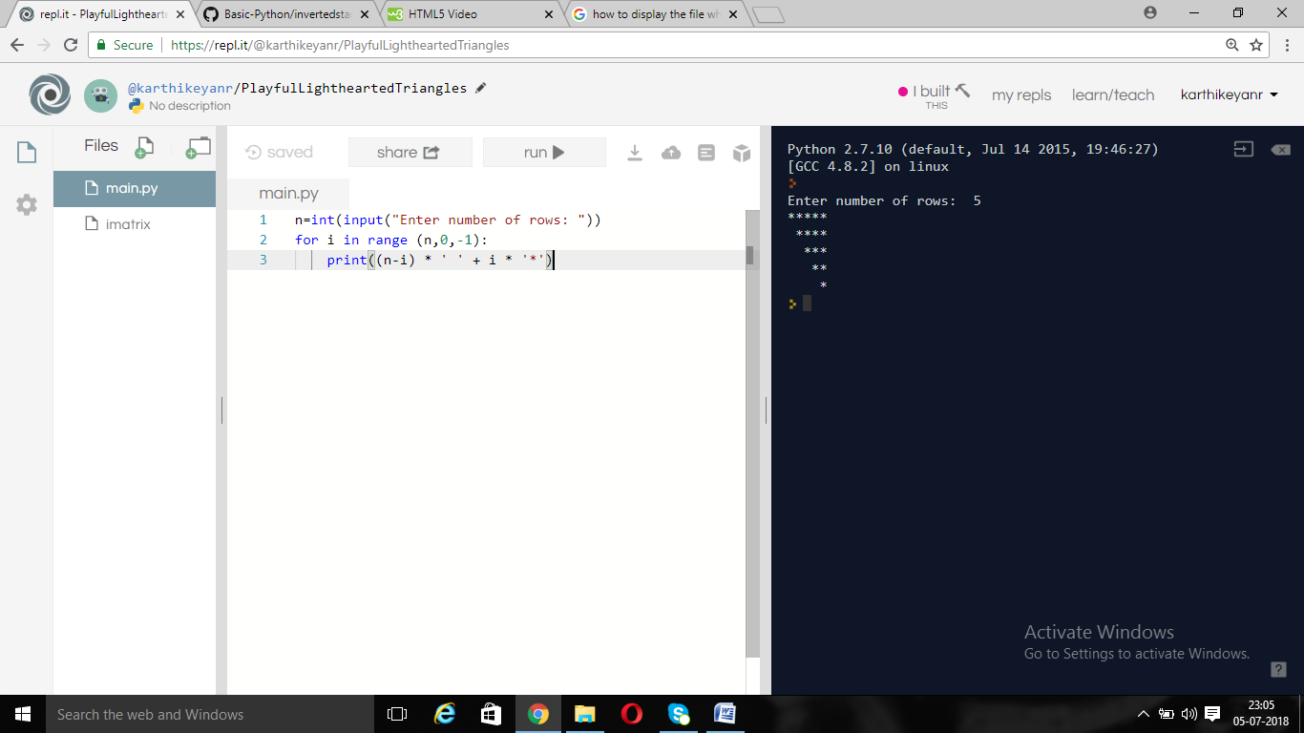

PROGRAM:

#Natural numbers

from __future__ import print_function

n=int(input("Enter a number: "))

a=[]

for i in range(1,n+1):

print(i,sep=" ",end=" ")

if(i<n):

print("+",sep=" ",end=" ")

a.append(i)

print("=",sum(a))

print()

OUTPUT:

